**GenAI**

**CA-II**

**Assignment**



**Name: Minal Shendre**

**PRN: 21070521042**

**Section: A**

**Q:1 Generate a model in Python for representation of a bank account of type savings and**

**balance along with transactions of deposits and withdrawals and currently create a program to**

**generate 100 accounts with Random balance and transactions for no. of months and no. of**

**transactions with a seed value of amount. Print all 100 accounts with the last balance and**

**organize them by lowest to highest balance.**

**Solution:** Flowchartto understand the flow of solution for the problem statement given.

**START**

**Initialize variables: num_accounts, seed, num_months, num_trans**

**Set random seed**

**Loop through each account: i. Generate random balance ii. Create SavingsAccount**

**Loop for months and transactions: i. Randomly deposit/withdraw ii. Update balance**

**Add account to list**

**Sort accounts by balance (ascending)**

**Print account details**

**END**

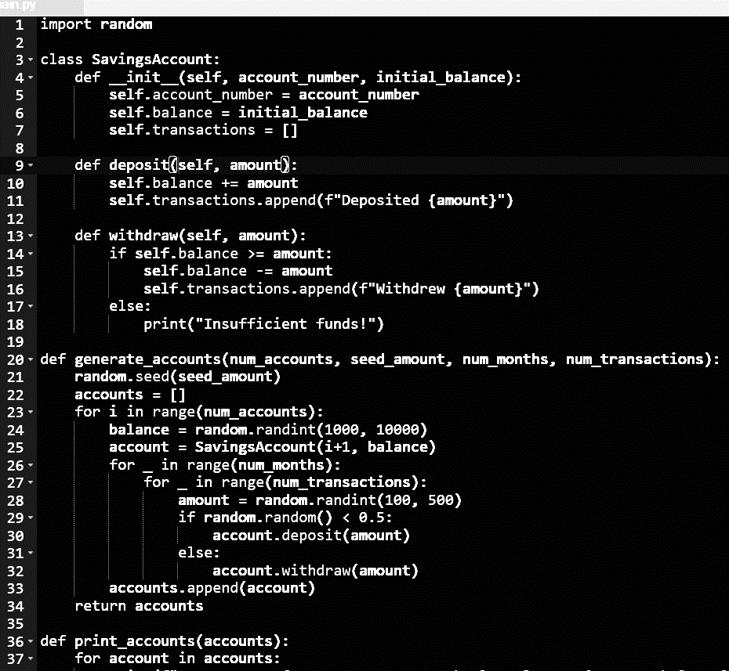**Code:**

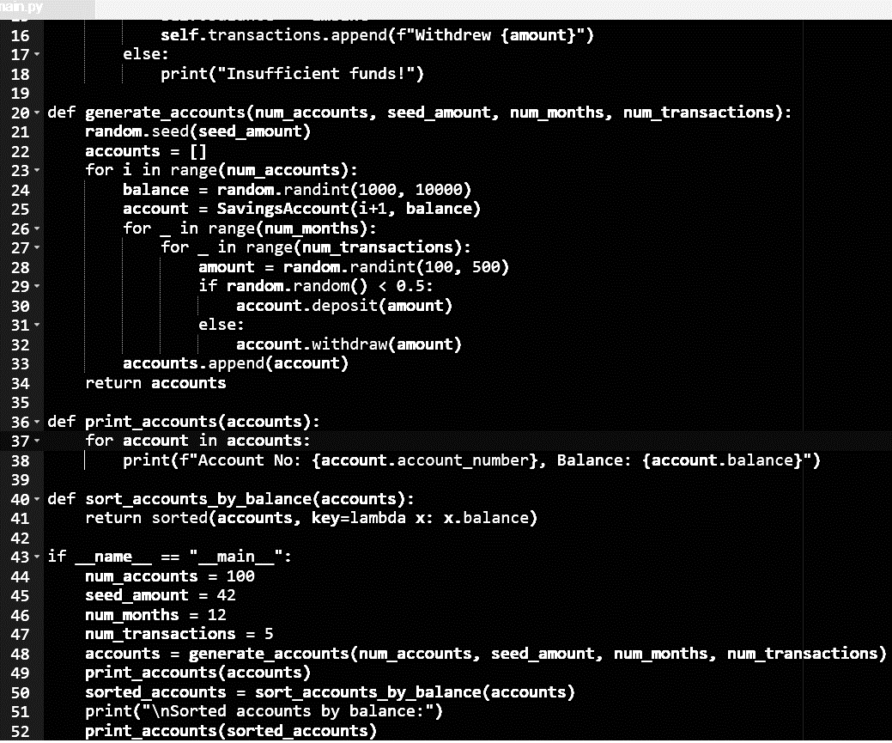

**END**

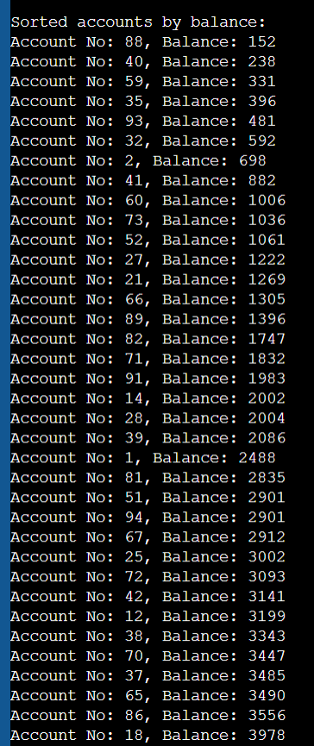Output:

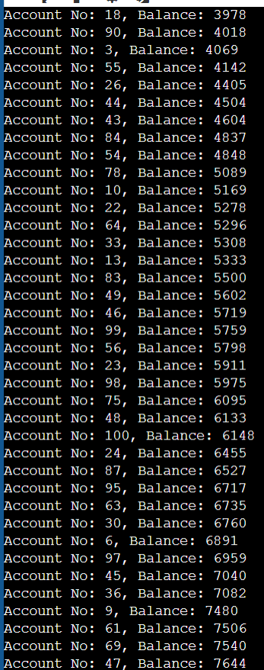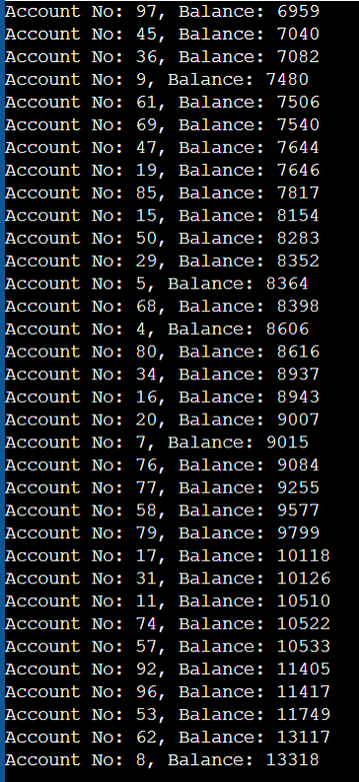

**Q: 2 Generate a model to represent a mathematical equation, write a program to parse the**

**Equation, and ask for input for each parameter.**

**Solution:** Flowchartto understand the flow of solution for the problem statement given.

**START**

**Print “Solving f(x,y)=ax^2+by+c”**

**Get user input (a,b,c,x,y)**

**Valid input?**

**No**

**Yes**

**Print “Invalid input” and return**

**Solve equation: ax^2 + by+ c**

**Print the result of the equation**

**END**

**Code:**

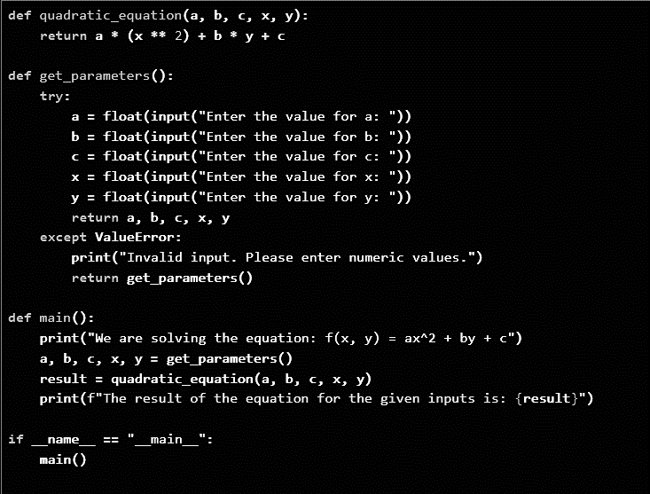

**Output:**

